**F. Y. B. Tech Academic Year 2021-22 ECE101B: Basics of Electrical and Electronics Engineering**

**Trimester: III Assignment 2**

**Subject:** Basics of Electrical and Electronics Engineering **Trimester: I**

**Name:** Shreerang Mhatre **Division:11**

**Roll No:** 111056 **Batch: K3**

**------------------------------------------------------------------------------------------------------------------------------**

**Date: 18/02/2022 Max. Marks: 25 Submission Date: 25/02/2022**

**Course Outcomes (COs) Covered:**

1. Predict the behavior and characteristics of basic electrical and magnetic circuits. (CLII)
2. Identify components/equipment required for any particular application related to electrical and electronics engineering. (CL-II)

**Instructions:**

1. **Q I is a set of 10 MCQs. Each MCQ carries one mark.**
2. **Q II, Q III, Q IV each carry 5 marks.**
3. **Please note that for Q II, Q III, Q IV, the component values are to be selected based on your division and roll number as mentioned in the question.**

**Q I. Select the answer of the following MCQs-**

1. Calculate the Thevenin resistance across the terminal AB for the following circuit.

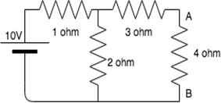

ANS: B) 3.67 ohm

1. Ra is resistance at A, Rb is resistance at B, Rc is resistance at C in star connection. After transforming to delta, what is resistance between B and C?

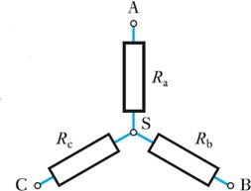

ANS: A) Rc+Rb+Rc*Rb/Ra

1. Calculate the current through 20 ohm resistor.

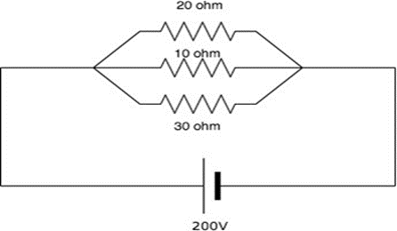

ANS: C) 6.67A

1. KCL is associated with

ANS: B) Nodal analysis

1. In superposition theorem, when we consider the effect of one current source, all the other current

sources are

ANS: B) Opened

1. A capacitor of 63 micro-F is connected across the voltage source of 230 V, 50 Hz. Current flowing through capacitor is

ANS: B) 4.55 A

1. A voltage source of 230 V, 50 Hz is applied across ideal inductor of 0.11 mH. In this circuit,

ANS: A) Current lags the voltage by 900

1. A series electric circuit contains resistance of 75 Ohm, capacitor of 5micro-F and inductor of 0.1 mH. At resonance impedance of the circuit is

ANS: C) 75 + j (XC-XL)

1. An alternating voltage has equation , what is value of frequency and RMS voltage .

ANS: A) 75Hz, 100v

10) The power factor at resonance in R-L-C parallel circuit is

ANS: D) Unit

**Q. II**

Assume V1= students division number, R2= addition of last three digits of student’s roll number (R2 is in Ω), R1=5Ω, R3=3Ω and I1=8A. Using Superposition theorem, find current flowing through R2.

Comment on result. Refer the circuit shown below.

**( For ex. If your Div is XIV then V1= 14 V and if Roll No is 114016 then R2= 1+6= 7 Ω )**

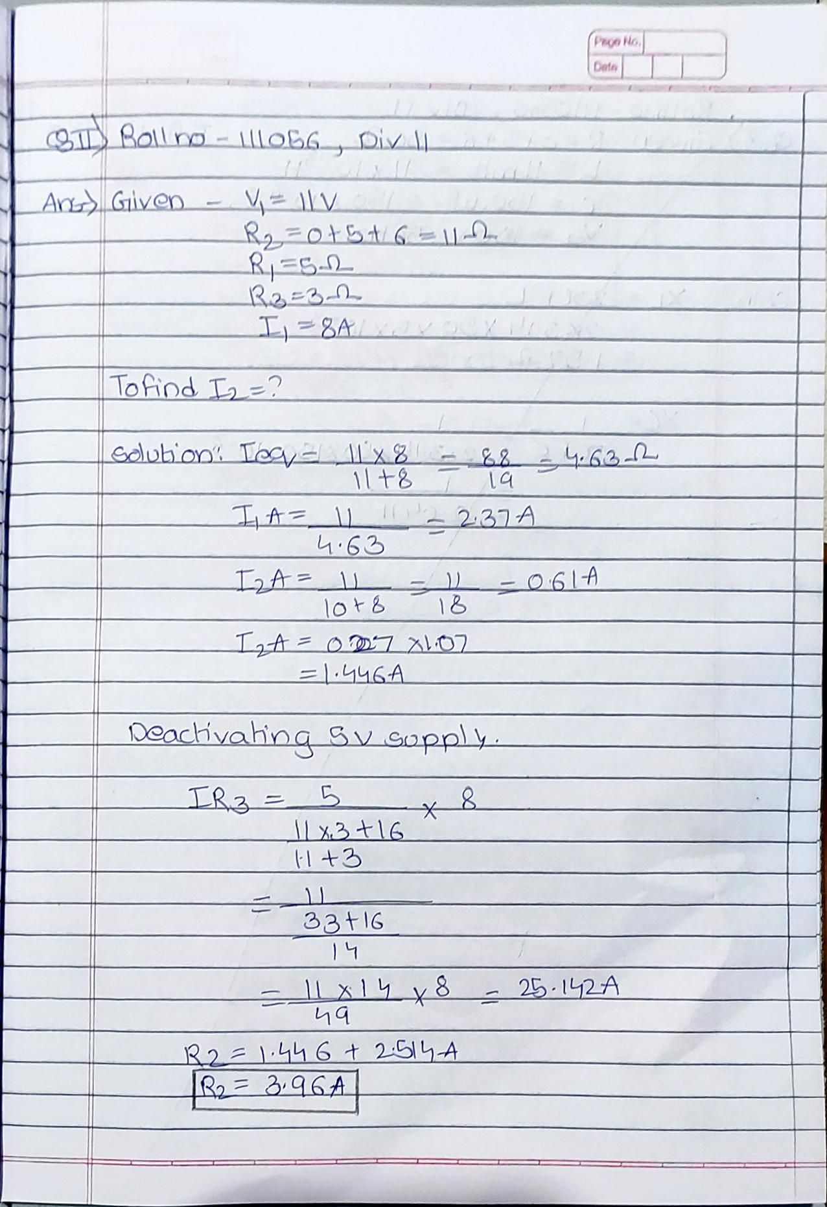

**Q.III**

A circuit having following components in series a resistance R = last three digits of Roll No **(** Ω),

an inductance L **=** your division number **(** mH) and a capacitance C = 150 μF, is connected across a 150 V, 50 Hz supply.

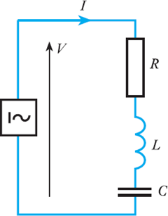**( For ex. If your Div is XIV then L = 14 mH and if Roll No is 114016 then R= 16 Ω )**

Calculate:

1. the impedance
2. the current
3. the voltages across R, L and C

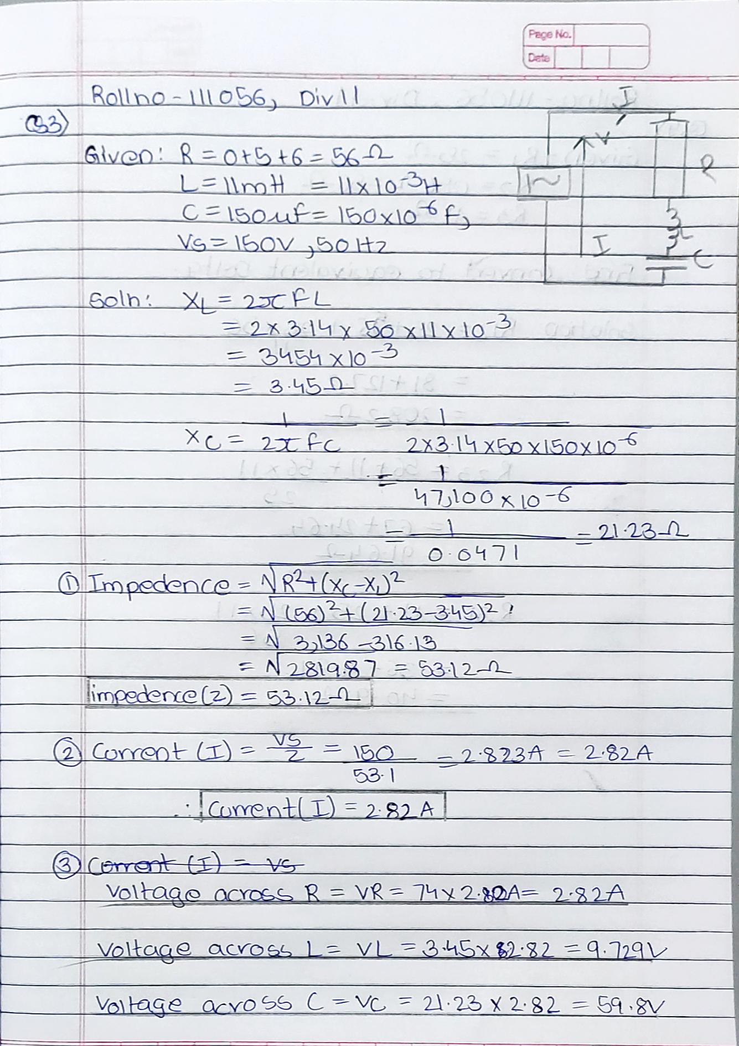

**Q IV**

Convert the following star network into its equivalent Delta network by taking the values of R1, R2 & R3 as follows.

R1 = 25Ω (fixed)

R2 = last three digits of your roll no R3 = Your division no.

**( For ex. If your Div is XI then R3 = 11 Ω and if Roll No is 111050 then R2= 050 Ω )**

